Adding an user:

https://support.cloud.tamu.edu/cloud_providers/azure/azure-group-mgmt/

1) Navigate to the Azure Portal: https://portal.azure.com/#home
Login using tamu account

2) Use the "Search resources, services, and docs" to locate the "Groups" console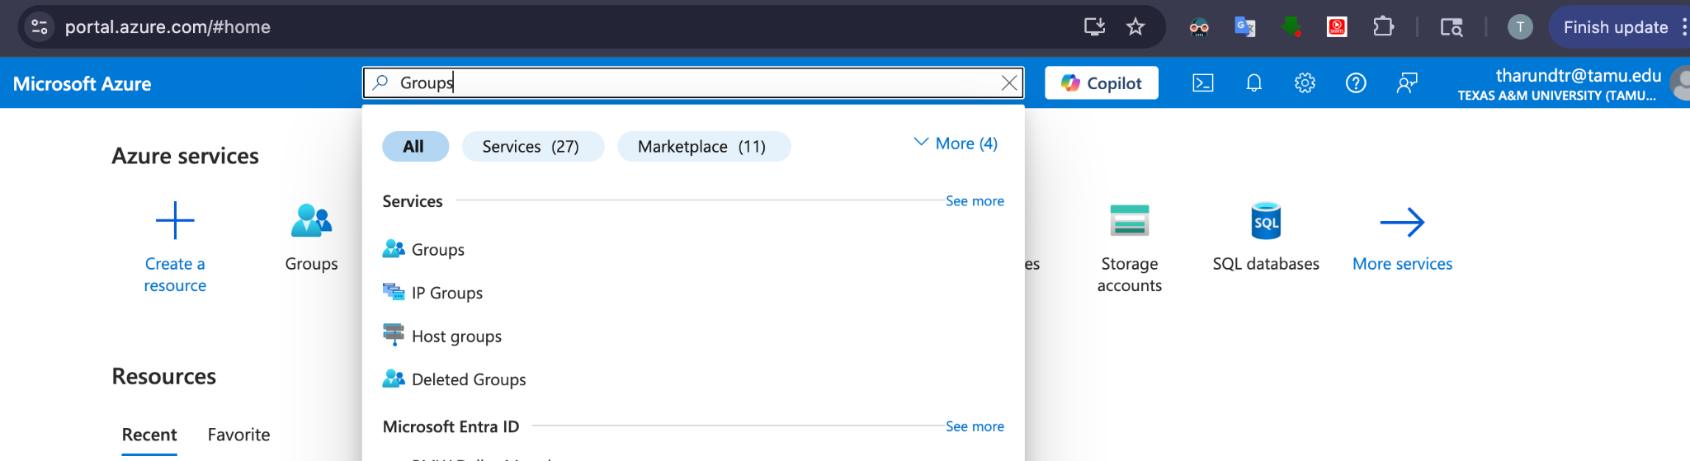

3) Use the "Search groups" box to search for the name of the subscription/account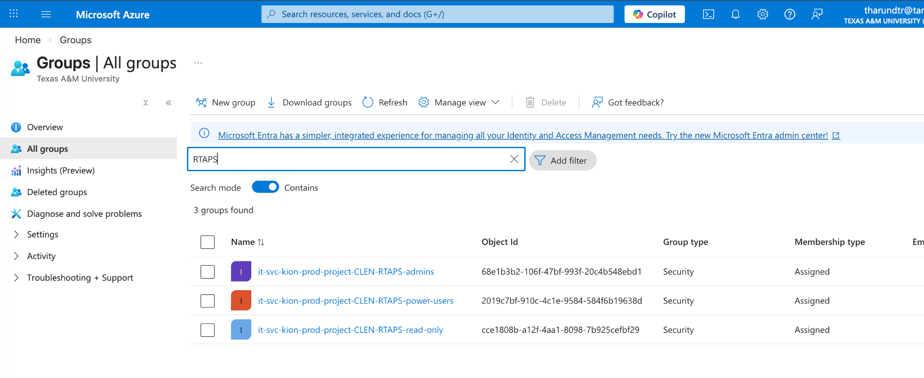

Click on
I
it-svc-kion-prod-project-CLEN-RTAPS-admins

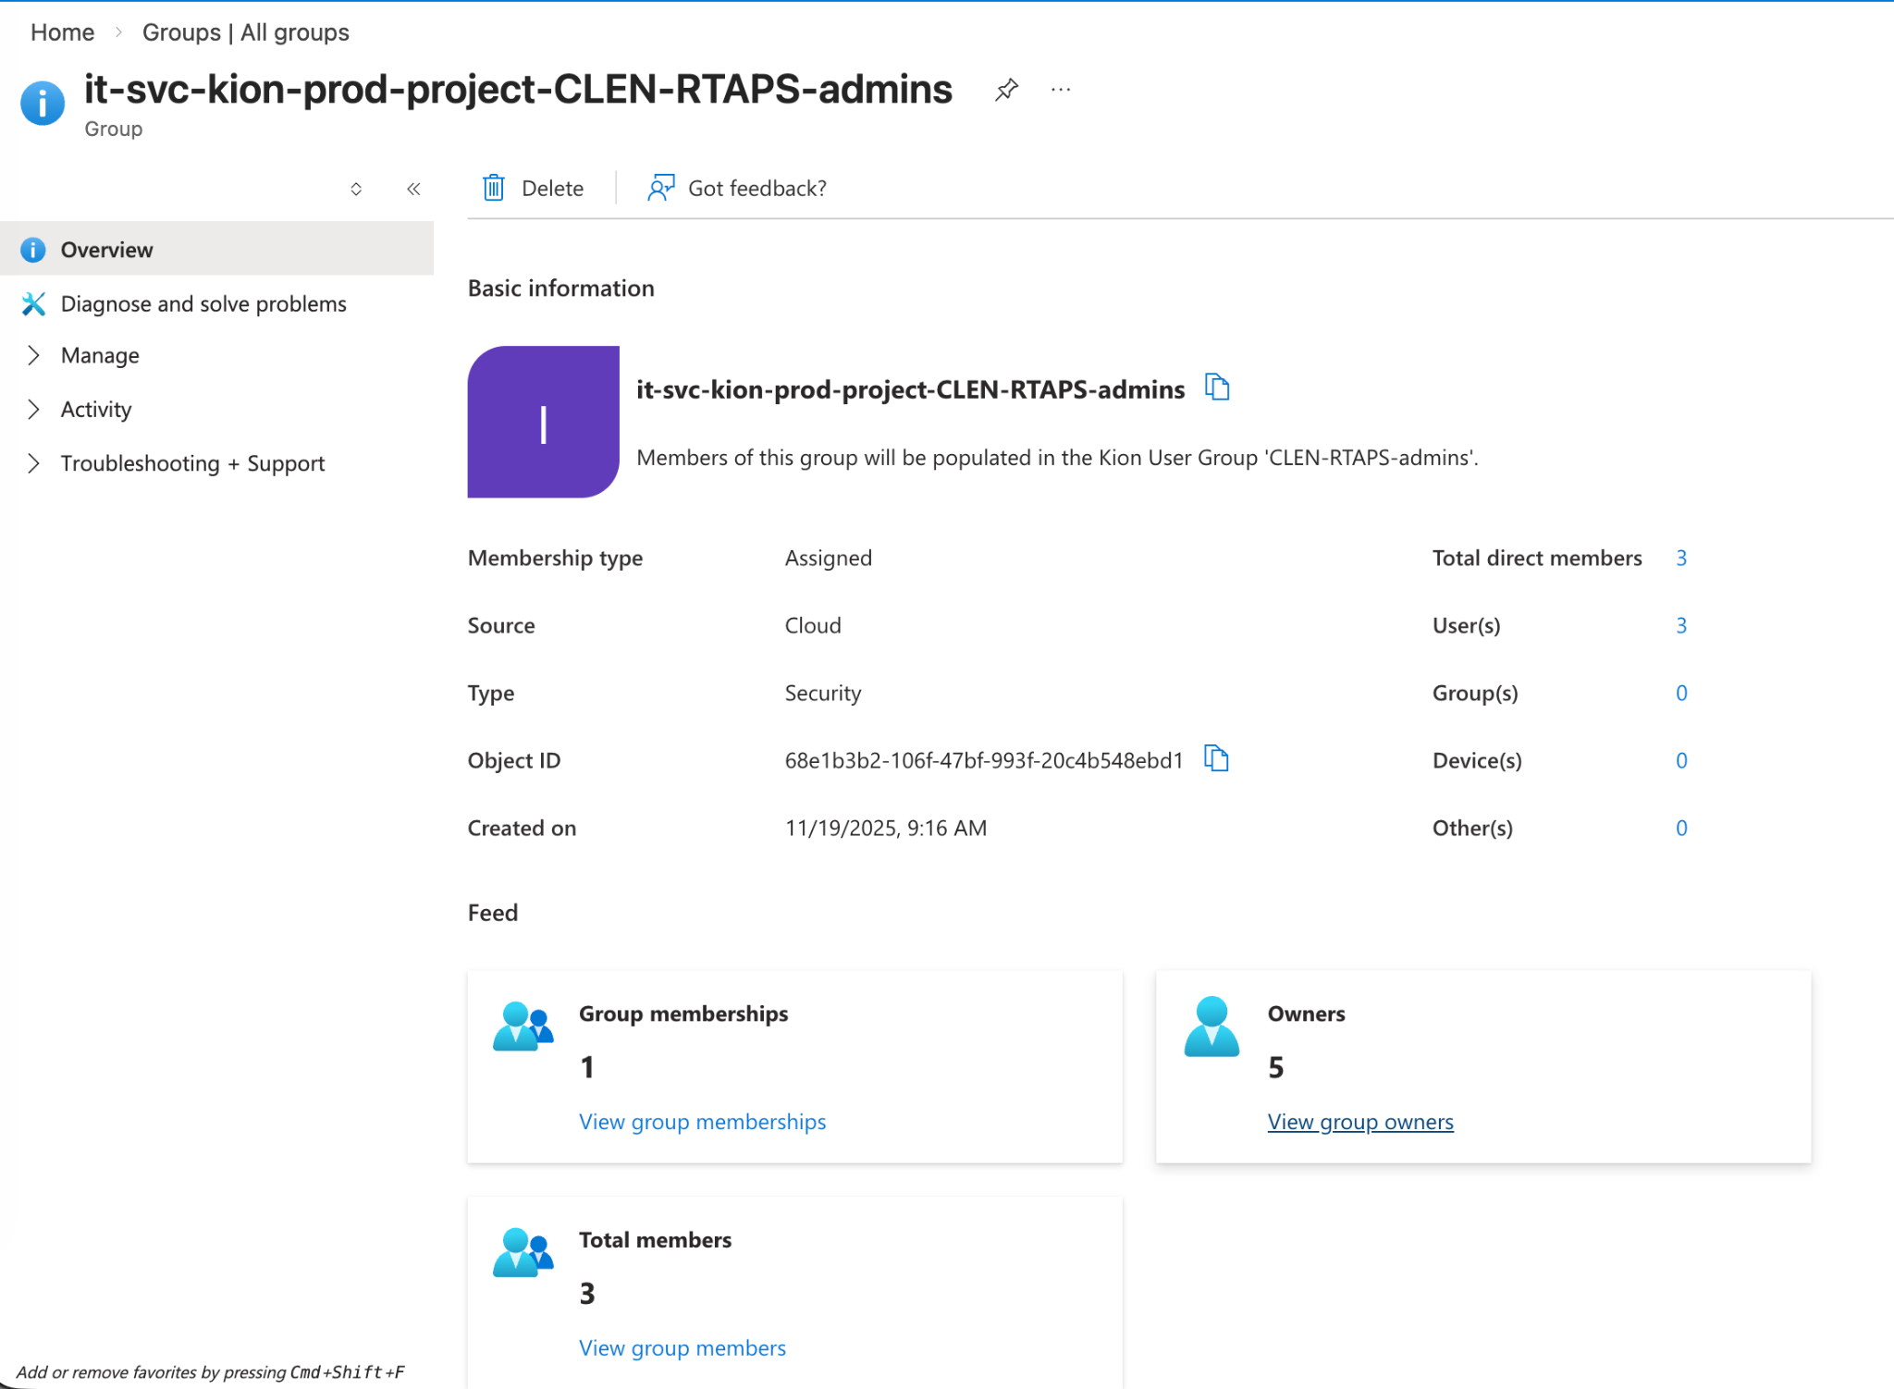

Click on view group owners
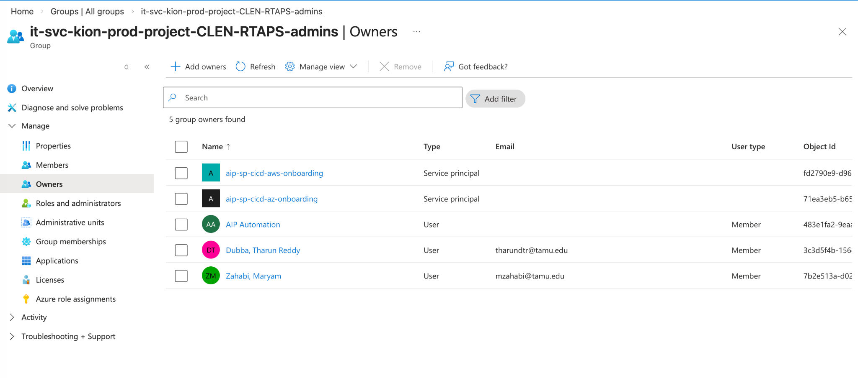
You can add/remove new users here directly.

New users can access to the AWS portal using the following link:
https://kion.cloud.tamu.edu/login

You can still check the users at the following link but can edit it only using the above process.
https://kion.cloud.tamu.edu/portal/ugroup

Unsubscribing from the AWS project:
Please contact cloudops@tamu.eduto submit a form to initiate the cancellation process.

Please find the details that have been used to provision the resource at the start
(Ticket #432287):

Description
Resource Owner: Tharun Dubba
Secondary Owner: Maryam Zahabi
Department: 02-CEN-College Of Engineering - Admin - Dean
Platform: aws
Resource Name: RTAPS
Resource Description: Research focuses on developing an intelligent, tablet-based system that predicts human performance errors during procedural tasks using gaze and behavioral data. The goal is to provide real-time adaptive feedback to improve task accuracy, reduce cognitive workload, and enhance human-system interaction in complex operational environments.
Network size: 27
Network Plan:
Additional comments:
FAMIS Account: 23-409441-00002
Billing Dept: 316
Annual budget: 250
Billing Contact: 0a97bdb1-c606-ef11-aaf2-f57c90d19764
Server Admin: false
Data Classification: University-Internal
Data Classification URL: N/A

